Project Planning Phase
Project Planning Template (Product Backlog, Sprint Planning, Stories, Story points)

Date | 15 February 2025
Team ID | LTVIP2026TMIDS91514
Project Name | TransLingua – AI-Powered Multi-Language Translator
Maximum Marks | 5 Marks

Product Backlog, Sprint Schedule, and Estimation (4 Marks)
Use the below template to create product backlog and sprint schedule
Sprint | Functional Requirement (Epic) | User Story Number | User Story / Task | Story Points | Priority | Team Members
Sprint-1 | Application Setup | USN-1 | As a developer, I can set up the Python virtual environment and install dependencies. | 2 | High | Team
Sprint-1 | UI Development | USN-2 | As a user, I can enter text for translation. | 2 | High | Team
Sprint-1 | Language Selection | USN-3 | As a user, I can select source and target languages. | 2 | High | Team
Sprint-1 | API Integration | USN-4 | As a system, I can integrate Google Gemini API for translation. | 5 | High | Team
Sprint-2 | Security Implementation | USN-5 | As a developer, I can store API keys securely using environment variables. | 3 | High | Team
Sprint-2 | Output Display | USN-6 | As a user, I can view translated text instantly. | 2 | High | Team
Sprint-2 | Testing | USN-7 | As a developer, I can perform functional testing. | 3 | Medium | Team
Sprint-2 | Documentation | USN-8 | As a developer, I can prepare GitHub repository and documentation. | 5 | Medium | Team

Total Story Points per Sprint
Sprint-1 = 2 + 2 + 2 + 5 = 11 Story Points
Sprint-2 = 3 + 2 + 3 + 5 = 13 Story Points
Total Story Points = 11 + 13 = 24

Project Tracker, Velocity & Burndown Chart: (4 Marks)
Sprint | Total Story Points | Duration | Sprint Start Date | Sprint End Date (Planned) | Story Points Completed | Sprint Release Date
Sprint-1 | 11 | 10 Days | 15 Feb 2025 | 24 Feb 2025 | 11 | 24 Feb 2025
Sprint-2 | 13 | 10 Days | 25 Feb 2025 | 06 Mar 2025 | 13 | 06 Mar 2025
Sprint | Total Story Points | Duration | Sprint Start Date | Sprint End Date (Planned) | Story Points Completed | Sprint Release Date
Sprint-1 | 11 | 10 Days | 15 Feb 2025 | 24 Feb 2025 | 11 | 24 Feb 2025
Sprint-2 | 13 | 10 Days | 25 Feb 2025 | 06 Mar 2025 | 13 | 06 Mar 2025
Sprint | Total Story Points | Duration | Sprint Start Date | Sprint End Date (Planned) | Story Points Completed | Sprint Release Date
Sprint-1 | 11 | 10 Days | 15 Feb 2025 | 24 Feb 2025 | 11 | 24 Feb 2025
Sprint-2 | 13 | 10 Days | 25 Feb 2025 | 06 Mar 2025 | 13 | 06 Mar 2025

4. Velocity Calculation
Velocity = Total Story Points Completed / Number of Sprints
Total Story Points = 24
Number of Sprints = 2
Velocity = 24 / 2 = 12 Story Points per Sprint
If sprint duration is 10 days,
Average Velocity per Day = 12 / 10 = 1.2 Story Points per Day

5. Burndown Chart Description
A burndown chart represents the remaining work against time during a sprint.
For this project, each sprint started with its respective total story points and gradually reduced to zero by the planned sprint end date. This indicates systematic progress and effective sprint management.
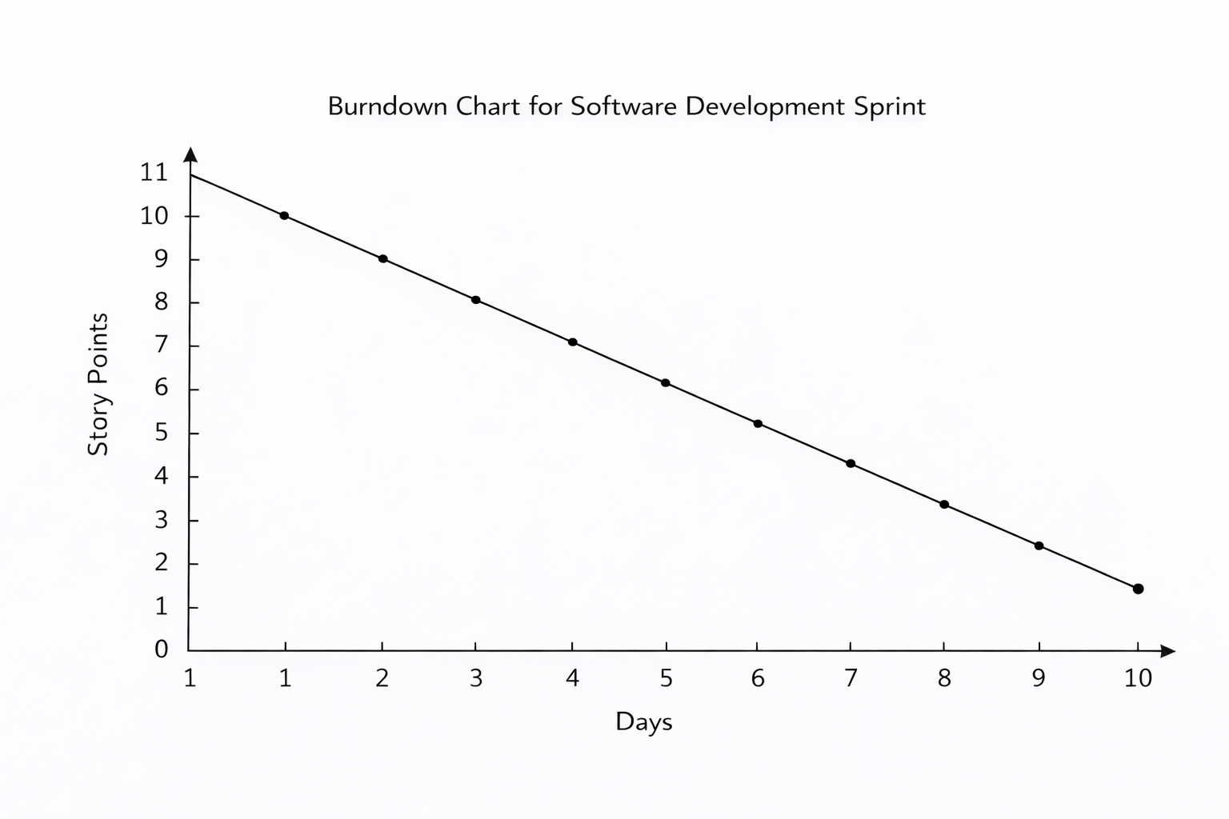

Burndown Chart:
A burn down chart is a graphical representation of work left to do versus time. It is often used in agile software development methodologies such as Scrum. However, burn down charts can be applied to any project containing measurable progress over time.

https://www.visual-paradigm.com/scrum/scrum-burndown-chart/
https://www.atlassian.com/agile/tutorials/burndown-charts

Reference:
https://www.atlassian.com/agile/project-management
https://www.atlassian.com/agile/tutorials/how-to-do-scrum-with-jira-software
https://www.atlassian.com/agile/tutorials/epics
https://www.atlassian.com/agile/tutorials/sprints
https://www.atlassian.com/agile/project-management/estimation
https://www.atlassian.com/agile/tutorials/burndown-charts

